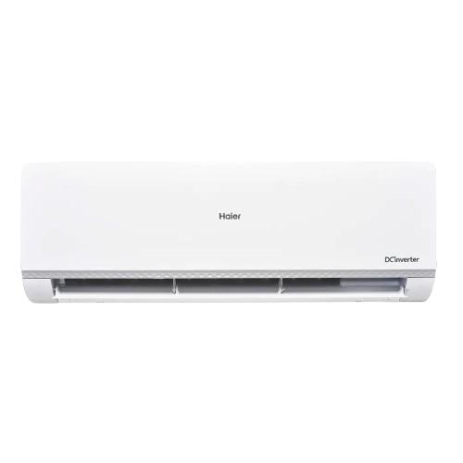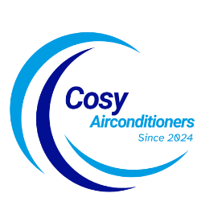

**Product details**

SKU: HSU-18HJ/012USDC(G)

**Puri Inverter**

~~Rs 185,999.00~~ Rs 174,900.00

Air Purification

Wide Voltage Range With Hyper PCB

Self Cleaning

With adoption of optimized cooling system, the cooling capacity of Haier Air Conditioners still could catch up 100% to provide the best cooling experience to user at 46◦C high temperature.

**THANK YOU!**

**WELLCOME TO OUR WEBSITE**